“Minorities and Self-determination – 100th Anniversary of the Post-World War I Plebiscites”
Paper Submission Form
Name:

Affiliation:

Academic Position:

Abstract: | Please insert abstract here – maximum 300 words.
Keywords: | Please supply us with 3 to 5 keywords related to your abstract.
 | 1.
 | 2.
 | 3.
 | 4.
 | 5.
Panel | Please specify which panel/s your paper would be intended.
Travel Assistance Grant | Please indicate here if you wish to be considered for a travel assistance grant.

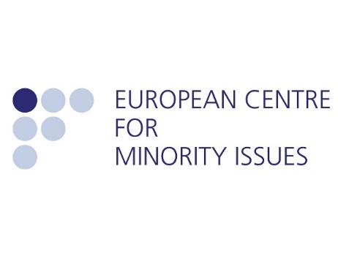
Please send this form as an attachment with a cover email to conference2020@ecmi.de. Deadline 15th October 2019.

